CPR Broker
PART standard
Core Engine
Design specification

Magenta Aps
Contents
1 Overview 3
2 PART Operations 4
2.1 Create 5
2.2 Import 6
2.3 Read 7
2.4 Right 8
2.5 Delete 9
2.6 Deactivate 10
2.7 Search 11
2.8 List 11

Overview

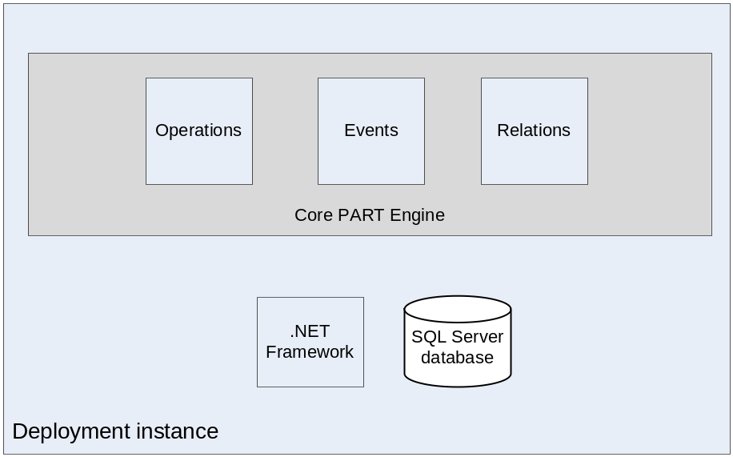

PART Operations
In this section, there is a description of each operation of the operations required by the standard. This text will focus on the technical implementation and the used algorithm rather than the requirements which are already specified by the standard.
A common property of all operations is that operations run as a transaction. This means that it is either run fully or rejected fully.

Create
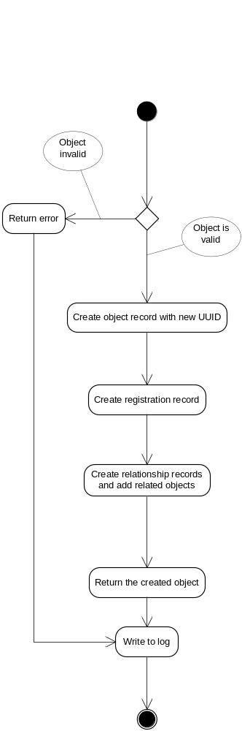

Import
This process is very similar to Create, but the object ID here is taken from the input object. It is validated that the object ID is not in the database.
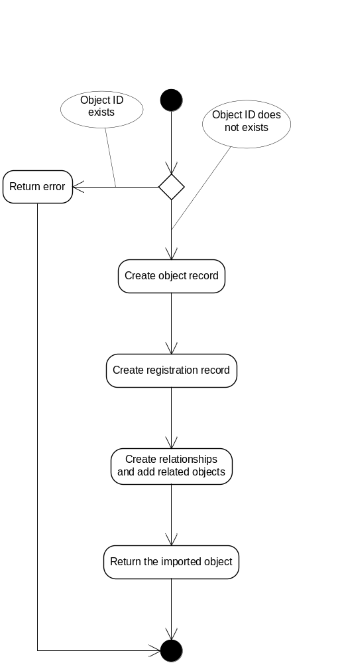

Read
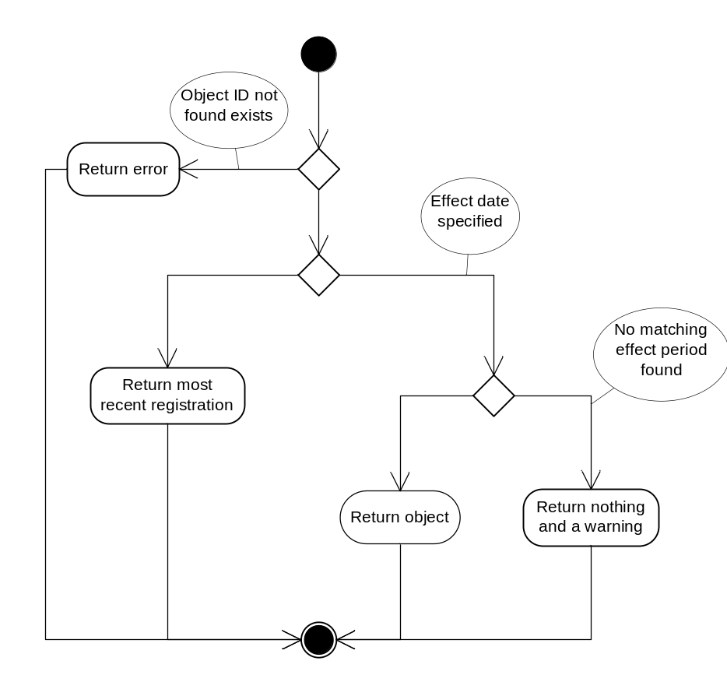

Right
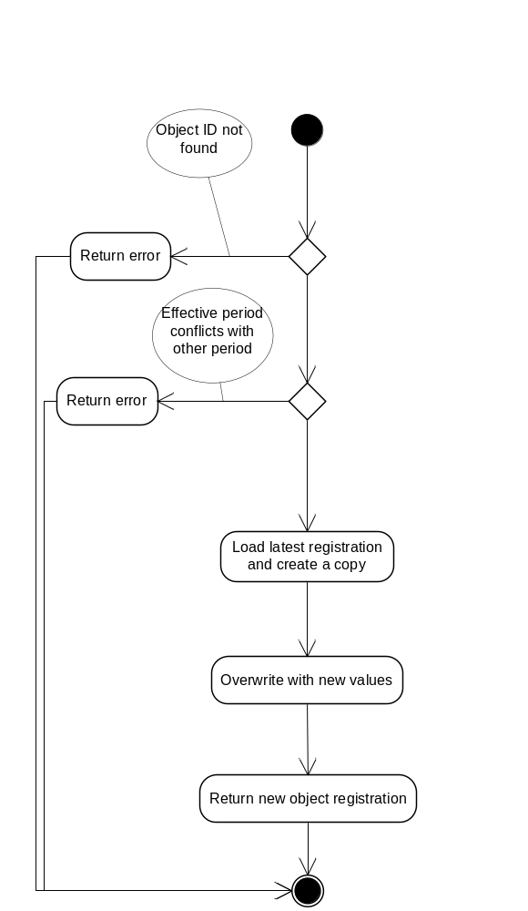

Delete
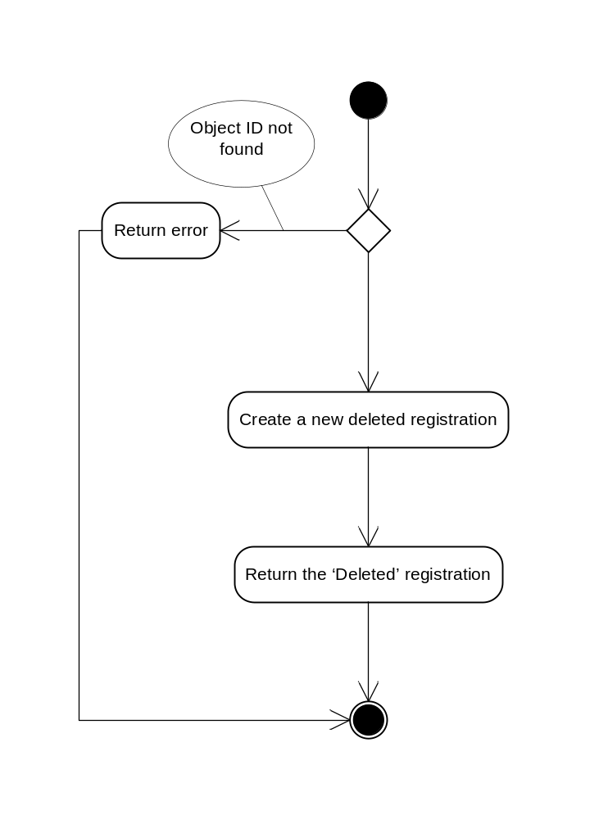

Deactivate
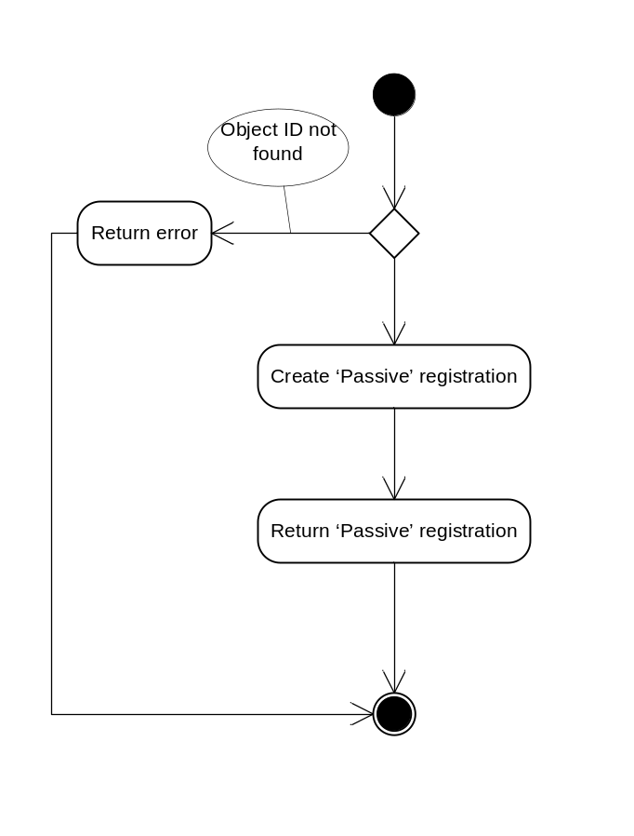

Search
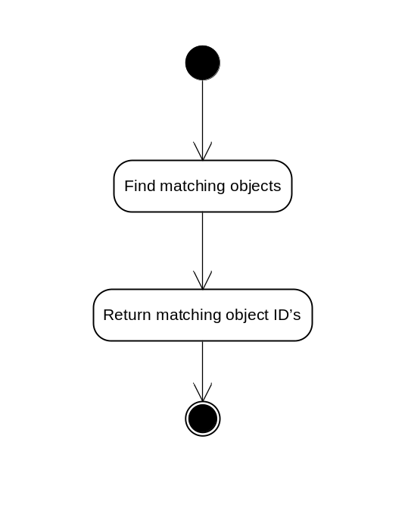

List
